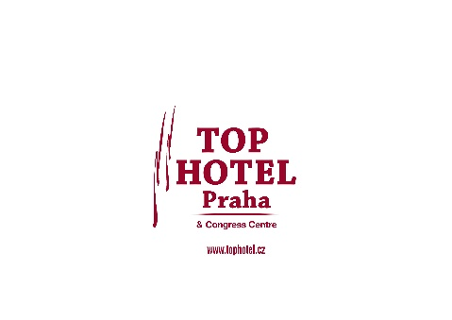
RESERVATION FORM
TOP HOTEL Praha****, Blažimská 1781/4, 149 00 Praha 4 - Chodov

PLEASE FILL IN RESERVATION FORM AND SEND IT TO:
revenue@tophotel.cz  tel.:+420 267 284 260  Final term for reservation: 6.6.2025 |  | PASSWORD: „CZECH OPEN CUP“
RESERVATION DETAILS

DATE OF ARRIVAL :

DATE OF DEPARTURE:

 |  |  | Nr. of rooms |  | Nr. of pax
SINGLE ROOM
DOUBLE ROOM
TRIPLE ROOM
NAME :
INVOICE DETAILS :
Roommate´s name :
Phone number: |  | E-mail:
Signature:

PRICE LIST (20.-22.6.2025):
Single room with breakfast | 71€/night/room
Double room with breakfast | 75€/night/room
Triple room with breakfast | 96€/night/room
Price includes breakfast, city tax and VAT .
Payment procedure:
- Payment on spot at check in – by credit card or cash ( CZK or €)
- We can also send you proforma invoice for 100% prepayment via bank transfer in CZK or €.

By signing this form you agree with our accommodation conditions and confirm that provided information is true and correct.

